Supplementary Material

Integrative Mendelian Randomization and Proteomic Analyses Reveal Genetically Supported Candidate Causal Biomarkers for Non-Traumatic Osteonecrosis of the Femoral Head
‡ Zhangzheng Wang, ‡Liang Mo, Wei He, Youwen Liu, Csaba Matta, Yuhao Liu

* Corresponding Author(s):
Yuhao Liu (doctor_yuhaoliu@126.com)
12 Jichang Road, Guangzhou, China

Csaba Matta (matta.csaba@med.unideb.hu)
Egyetem tér 1, H‑4032 Debrecen, Hungary

Contents
Figure S1. Cell Subpopulation Annotation and Classical Marker Expression.
Figure S2. DotPlot of Four Causal Biomarkers from Musculoskeletal Tissues Across Cell Subpopulations.
Figure S3. Chord diagram showing the sender–receiver relationships of major signaling pathways among six cell subpopulations.

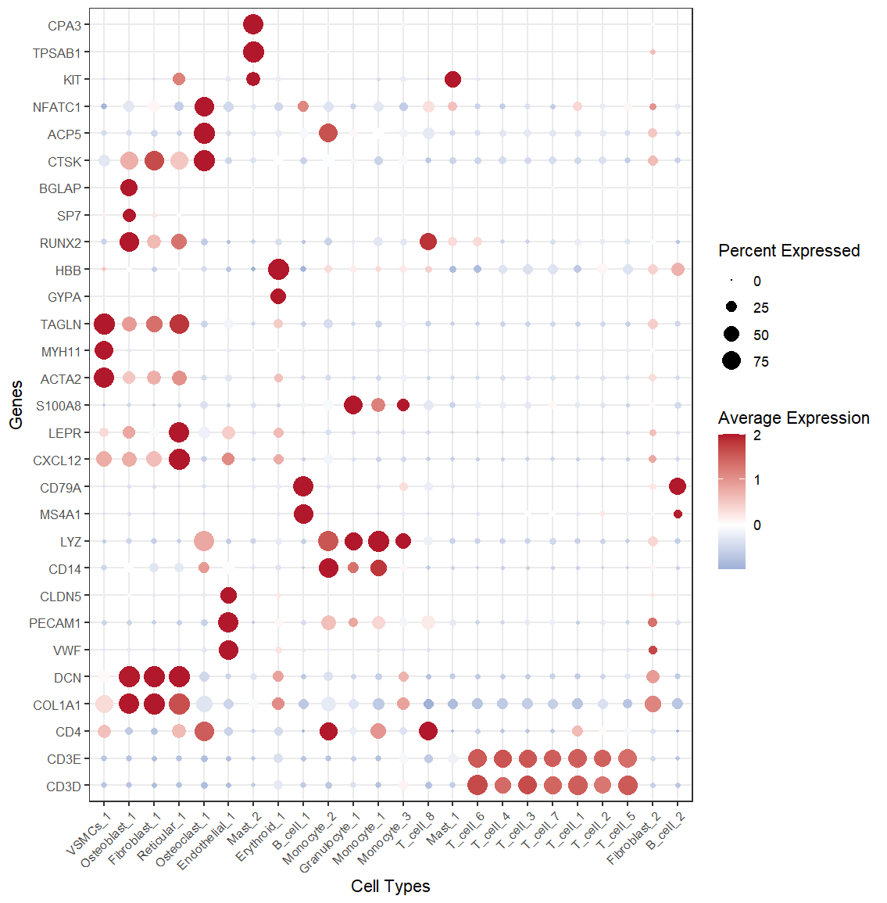
Figure S1. Cell Subpopulation Annotation and Classical Marker Expression.
24 clusters were defined as 12 major cell subgroups: T cells (CD3D, CD3E, CD4), Fibroblasts (COL1A1, DCN), Endothelial cells (VWF, PECAM1, CLDN5), Monocytes (CD14, LYZ), B cells (MS4A1, CD79A), Reticular cells (CXCL12, LEPR), Granulocytes (S100A8), Vascular Smooth Muscle Cells (VSMCs) (ACTA2, MYH11, TAGLN), Erythroid cells (GYPA, HBB), Osteoblasts (RUNX2, SP7, BGLAP), Osteoclasts (CTSK, ACP5, NFATC1), and Mast cells (KIT, TPSAB1, CPA3).

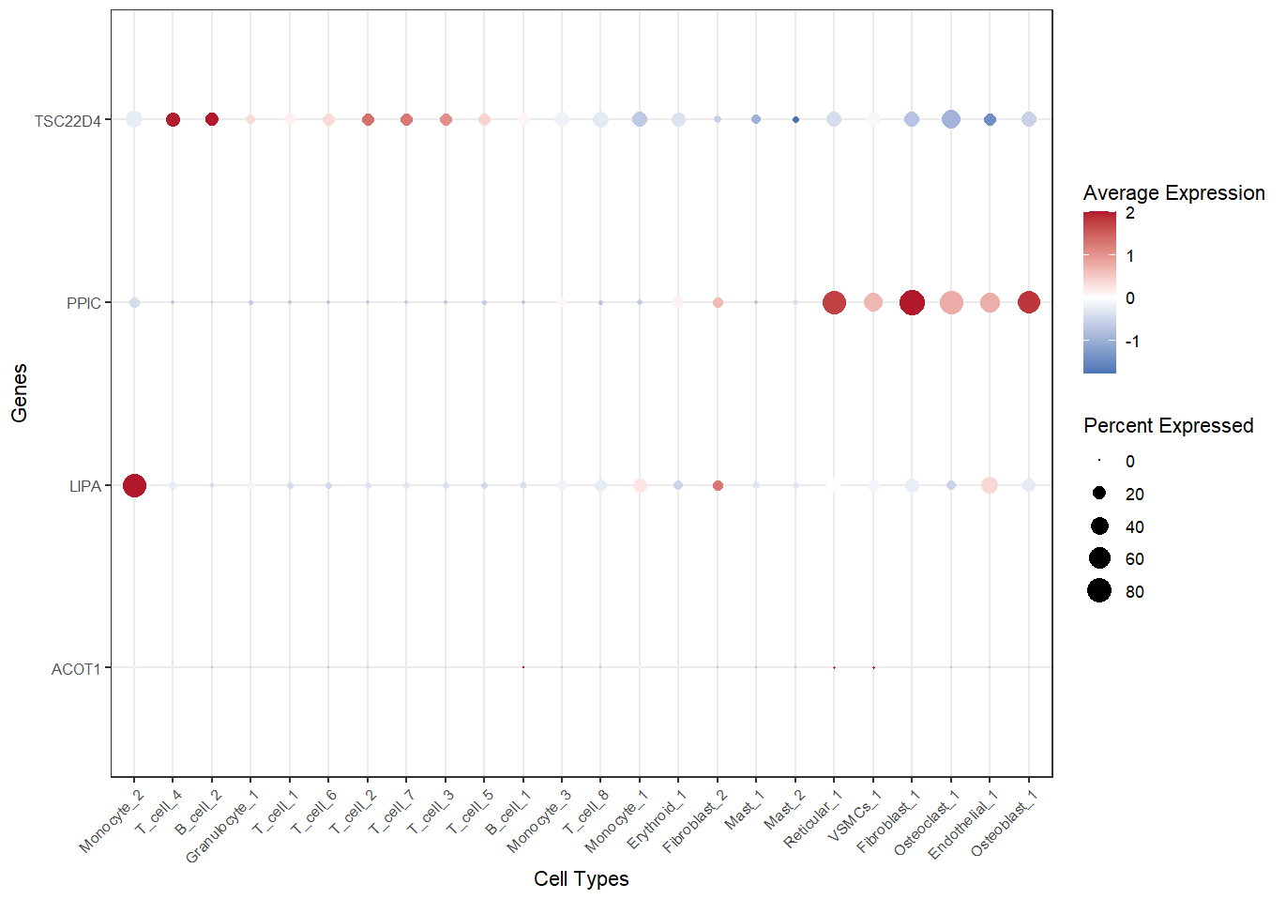
Figure S2. DotPlot of Four Causal Biomarkers from Musculoskeletal Tissues Across Cell Subpopulations.
TSC22D4 was predominantly highly expressed in T_cell_4 and B_cell_2, LIPA was mainly highly expressed in Monocyte_2, and PPIC was highly expressed in Fibroblast_1, Reticular_1, and Osteoblast_1. These six subpopulations were primarily included in the subsequent cell–cell communication analysis.

Figure S3. Chord diagram showing the sender–receiver relationships of major signaling pathways among six cell subpopulations.
Fibroblast_1 subpopulation acted as the primary sender for COLLAGEN and MIF signals, while Reticular_1 was the primary sender for MK signals.

